**CAPSTONE PROJECT – SPORTS ANALYSIS**

**OLYMPIC GAMES**

**DATA ANALYTICS**

**SRINATH M**

The analysis aims to uncover valuable insights from the historical data of the Olympic Games, examining games, sports, events, participants, medals, and regional representation. It seeks to identify trends, patterns, and key insights across multiple editions to provide a detailed overview of the Olympics' history and evolution. The study will offer recommendations to improve future Olympics' organization, sports selection, and regional representation, culminating in a comprehensive report and presentation of the findings.

**Overview**

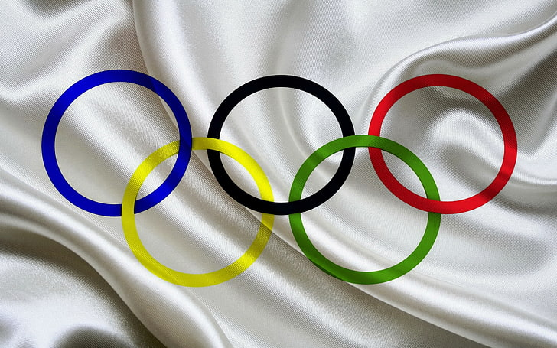

**THE PROCESS**

**1. Data Acquisition from GitHub:**

Obtain the requisite dataset from a designated GitHub repository, containing essential information. The analysis explores historical Olympic data to uncover trends, patterns, and insights into games, sports, participants, and medals. It aims to highlight the Olympics' evolution and provide recommendations for improving future organization and representation, presented in a detailed report and presentation.

**2. Data Transformation and Enhancement:**

If necessary, execute data transformation procedures to ensure data quality and consistency. Additionally, consider augmenting the dataset with new problem statements to enrich the analysis potential

**3. Connecting with Tools:**

Establish connections between the dataset and various analytical tools. Interface the dataset with Power BI, Excel, and MySQL Workbench, facilitating seamless data integration and processing.

**4. Problem Statement Solution in Power BI:**

Utilize Power BI to delve into the specified problem statements. Employ its robust features for data visualization, exploration, and analysis, effectively deriving insights and solutions.

**5. Exploratory Data Analysis (EDA):**

Perform exploratory data analysis using either Excel or SQL Workbench, depending on the complexity of the analysis. Extract meaningful patterns, relationships, and trends from the data to inform subsequent decision-making.

**6. Creation of Visual and Insightful PowerPoint:**

Develop a comprehensive PowerPoint presentation that encapsulates the project's objectives, methodologies, problem statement solutions, and key visualizations. Each problem statement should be accompanied by a dedicated section with pertinent conclusions and insights.

**7. Detailed Documentation:**

Compile a detailed report that meticulously documents the entire project lifecycle. Include sections on data collection, transformation, problem statement formulation, tools integration, Power BI solutions, EDA insights, and PowerPoint visualizations.

**OBJECTIVES**

**Understand the Historical Evolution of the Olympic Games**

* + Explore the history of the Olympic Games, from their inception in 1896 to recent editions, including both Summer and Winter Games.
  + Analyse trends in medal distributions, the introduction of new sports and events, and the progression of regional representation over time.
  + Highlight key moments in Olympic history that have shaped its evolution and global impact.

1. **Analyse Athlete and Event Dynamics**
   * Investigate athlete demographics, such as gender, height, and weight, to understand how athlete profiles have evolved across different eras.
   * Study participation trends in specific events, including patterns in gender-based and mixed-gender competitions.
   * Evaluate the relationships between sports, events, and medal outcomes to identify areas of consistent success and underperformance.
2. **Evaluate the Impact of Host Cities and Regional Participation**
   * Assess the influence of host cities on the success and participation of regional and international athletes.
   * Examine how hosting the Games affects regional representation, economic outcomes, and global engagement in sports.
   * Identify best practices and challenges from previous host cities to improve future event planning and selection.
3. **Identify Key Trends and Patterns in the Olympic Games**
   * Analyse historical medal trends to highlight periods of dominance by specific countries or regions.
   * Identify seasonal patterns in sports participation, the rise of emerging sports, and shifts in the popularity of specific events.
   * Examine changes in regional participation and success, focusing on the growth of representation from emerging nations.
4. **Promote Diversity and Inclusion**
   * Explore underrepresented regions and sports to provide recommendations for increasing participation and competitiveness.
   * Evaluate the effectiveness of mixed-gender events and propose strategies for expanding equitable opportunities for all athletes.
   * Recommend programs to support talent development in regions with limited medal success.
5. **Generate Insights for Future Olympic Strategies**
   * Provide actionable insights to inform the selection of future sports and events based on historical trends and participant engagement.
   * Offer recommendations for enhancing athlete experiences, improving inclusivity, and fostering global representation in the Games.
   * Suggest improvements in organizational practices, such as host city selection and event scheduling, to optimize the Games’ success.
6. **Deliver a Comprehensive Report and Presentation**
   * Compile a detailed report that consolidates findings from the analysis, highlighting trends, insights, and actionable recommendations.
   * Develop a visually engaging presentation to effectively communicate the historical significance and future strategies for the Olympic Games.
   * Ensure the report and presentation serve as valuable tools for decision-making and planning for future Olympic editions.
   * as valuable tools for decision-making and planning for future Olympic editions.

**SIGNIFICANCE**

The analysis of the Olympic Games dataset holds immense significance in understanding the evolution, impact, and global representation of this prestigious international event. By examining historical trends, athlete demographics, and regional participation, the study highlights the Games’ role as a unifying platform for diverse cultures and nations. It provides insights into the progression of sports, the introduction of new events, and the shifting dynamics of competitiveness, emphasizing the Olympics' adaptability and influence over time.

This analysis is crucial in promoting diversity and inclusion by identifying underrepresented regions and sports, as well as offering strategies to enhance equitable participation. By evaluating mixed-gender events and regional representation, it supports efforts to make the Olympics more inclusive and reflective of global talent. The insights also guide initiatives to support smaller nations and emerging regions, fostering broader global engagement and competitiveness.

Furthermore, the study underscores the impact of host cities on the Games' success, participation rates, and regional representation. By analyzing past patterns and challenges, the analysis provides actionable recommendations for future host city selection and organizational strategies. It also highlights the importance of emerging sports and evolving athlete profiles, ensuring the Olympics remain relevant and inclusive in a rapidly changing world.

Ultimately, the findings from this analysis will inform decision-making and planning for future Olympic editions, ensuring the Games continue to serve as a beacon of excellence, inclusivity, and unity. By delivering a comprehensive report and presentation, the study aims to support stakeholders in shaping a more impactful and sustainable future for the Olympic Games.

**DATA DICTIONARY**

**Sport Table**

This table contains a comprehensive list of all sports featured in the Olympics, covering both the summer and winter editions. Each sport is further categorized into specific events, catering to a wide range of athletic disciplines.

**Event Table**

The Event table offers detailed information about the various events held within each sport. Events are categorized based on gender, with separate entries for Men's, Women's, and Mixed events.

**City Table**

This table provides an extensive list of cities from around the world that have hosted or participated in the Olympic Games over the years.

**Games Table**

The Games table records every instance of the Olympic Games since its inception in 1896. It includes essential details such as the year in which the Games were held, as well as distinguishing between Summer and Winter Olympics.

**Games City Table**

This joining table establishes the relationship between the Games and City tables, capturing instances where the Olympic Games were jointly hosted by multiple cities, as seen in the case of the 1956 Olympics held in both Melbourne and Stockholm.

**NOC Region Table**

This table consists of NOC codes, representing National Olympic Committees, and their corresponding countries. It acts as a reference to identify the countries participating in the Olympic Games.

**Person Table**

The Person table records information about individuals who have competed in the Olympics. It includes their names, gender, height, and weight, with height and weight data remaining consistent across different Olympic editions.

**Person Region Table**

This joining table establishes connections between individuals and the countries they represented while competing in the Olympics. It accommodates scenarios where a person may have competed for multiple countries in different Olympic Games.

**Games Competitor Table**

This table serves as a joining table, linking individuals to specific Olympic Games, showcasing the participants and their involvement in each event.

**Medal Table**

A small table listing the different types of medals awarded at the Olympics, including Gold, Silver, Bronze, and N/A (indicating no medal).

**Competitor Event Table**

This table represents the largest one, providing crucial details about the combination of competitors, the events they participated in, and the medals they received, if any.

**ER DIAGRAM**

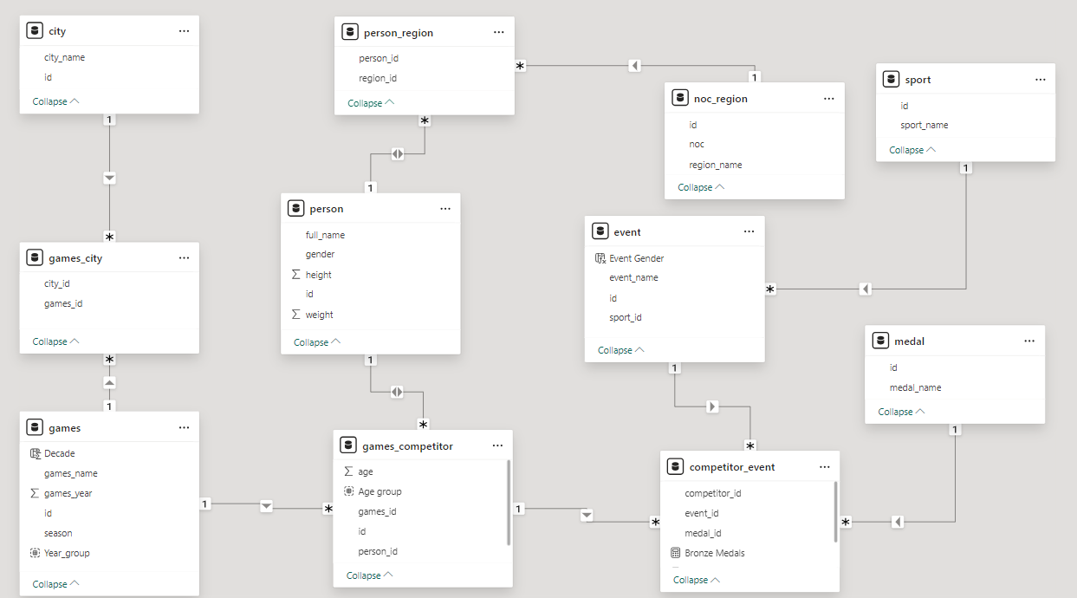

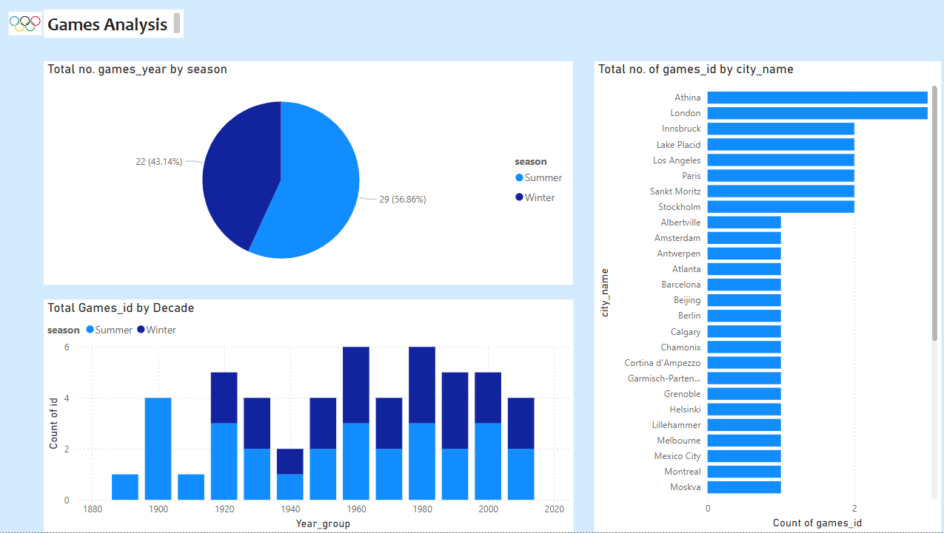

1. How many Olympic Games have been held in each season (Summer vs. Winter)?

The analysis of Olympic Games by season reveals the total number of Summer and Winter editions held throughout history. The Summer Olympics have traditionally been more frequent and widely attended, while the Winter Olympics have grown steadily since their inception. The study identifies patterns in the hosting frequency of each season, showing how both events have evolved over time. Over time, both editions have seen increasing diversity in host cities, reflecting the broader geographical reach of the Games. The analysis also highlights whether the frequency of the Games has remained consistent or if there have been notable changes in scheduling. Additionally, trends in the separation of Summer and Winter Games, provide insights into the strategic planning of the Olympics. Understanding these patterns helps in assessing the stability and growth of the Games across different seasons. These insights can guide future decisions on scheduling, host city selection, and the overall organization of the Olympic Games.

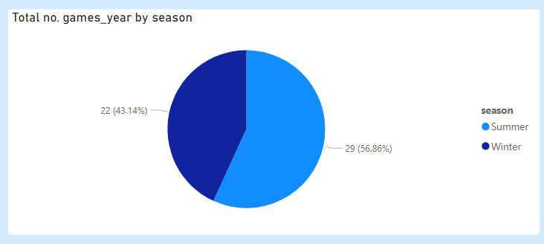

1. What is the distribution of games across different decades?

The analysis of Olympic Games distribution across decades highlights trends in their frequency, growth, and expansion. Initially, the Games followed a consistent schedule, with an increasing number of nations participating over time. Each decade saw the introduction of new sports, reflecting the evolving interests of athletes and audiences. The number of events and disciplines expanded, leading to a more diverse and inclusive Olympic program. As hosting opportunities spread across different continents, the Games became more globally representative. The introduction of new sports and changes in event formats contributed to keeping the Games dynamic and engaging. Recent decades have seen an increase in the scale and reach of the Olympics, attracting larger audiences and sponsorships. The analysis helps identify patterns in scheduling consistency and event distribution across different time periods. Understanding these trends supports better planning for future Olympic Games and ensures their continued growth and global impact.

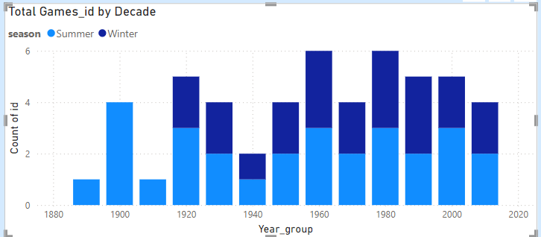

1. Which cities have hosted the most Olympic Games?

Olympic Games by analysing the Games City table, which links the Games and City tables. The city table contains city names, while the Games table records each Olympic edition since 1896. By counting the occurrences of each city in the Games City table, we can identify the most frequent hosts. Some cities have hosted multiple times, including London, Paris, and Los Angeles, which have each hosted three times. Athens, the birthplace of the modern Olympics, has hosted twice, including the inaugural edition in 1896. Tokyo has also hosted twice, and Beijing is another major host with multiple editions. Sydney, Rio de Janeiro, and Mexico City are examples of cities that have hosted once. The data also shows joint hosting, as seen in Melbourne and Stockholm (1956). These insights highlight the global distribution of the Olympics, with some cities becoming central hubs for the event's history.

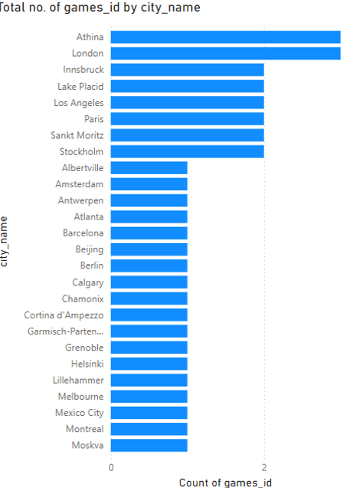

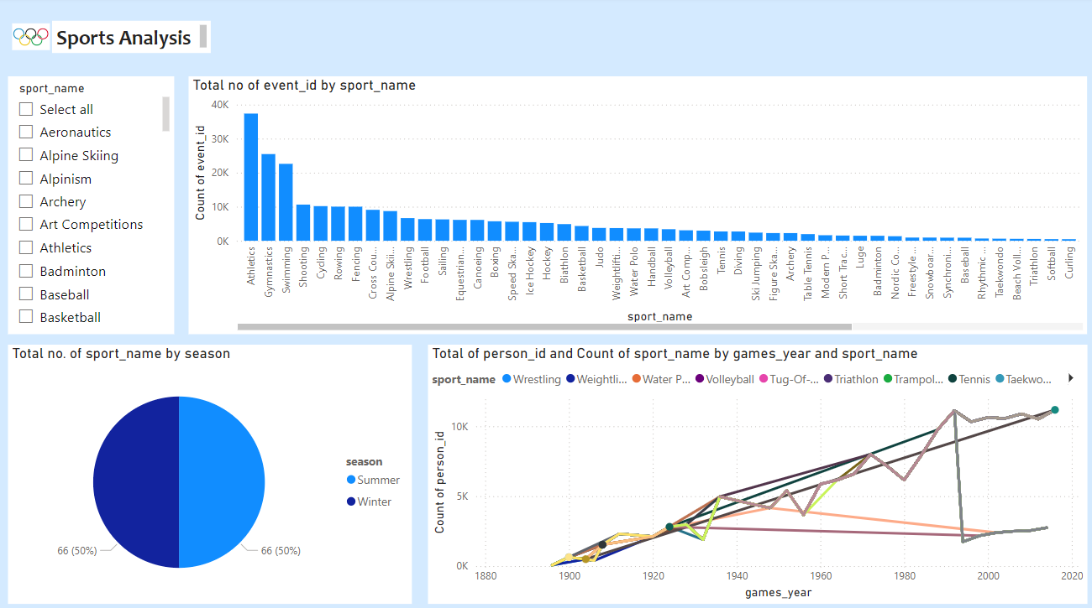

1. What is the distribution of sports between Summer and Winter Olympics?

Winter Olympics using the Games and Sport tables. The Games table contains details about each Olympic edition, including its season (Summer or Winter). The Sport table lists all sports featured in the Olympics, and its relationship with the Event table helps categorize them by Games. By joining these tables, we can determine that the Summer Olympics have a significantly higher number of sports compared to the Winter Olympics. Traditional Summer Olympic sports include Athletics, Swimming, Gymnastics, and Football, among others. The Winter Olympics feature sports like Alpine Skiing, Ice Hockey, Figure Skating, and Snowboarding, which are specific to cold-weather conditions. Some sports, such as Cycling and Rowing, are exclusive to the Summer Olympics, while others like Bobsleigh and Biathlon belong solely to the Winter Games. The dataset also indicates that new sports have been introduced in various editions, expanding the diversity of both Summer and Winter Games. Overall, the data highlights the distinct nature of these two Olympic seasons, with Summer Games having a broader range of sports and higher participation.

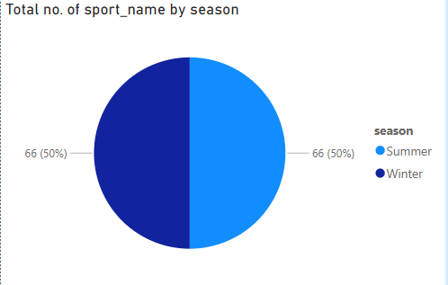

1. Which sports have the highest number of events in the Olympics?

we can determine the sports with the highest number of events by analysing the Sport and Event tables. The Sport table lists all sports, while the Event table provides details about individual competitions within each sport. By counting the number of events associated with each sport, we can identify the ones with the most events. Athletics has the highest number of events, covering track, field, and road races. Swimming follows closely, featuring multiple styles and distances for both men and women. Gymnastics also has a high number of events, including artistic, rhythmic, and trampoline disciplines. Other sports with numerous events include Cycling. Weightlifting and Wrestling have several weight-class-based events, increasing their total count. The data also suggests that some sports, like Shooting and Fencing, have historically had a large number of events due to multiple categories. Overall, the dataset highlights that sports with diverse disciplines and multiple weight categories tend to have the highest number of events.

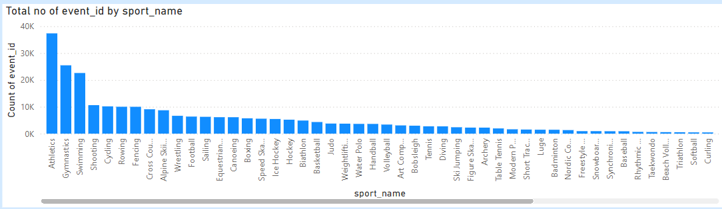

1. How has the participation in each sport evolved over time?

We can analyze the evolution of participation in each sport by examining the Games Competitor and Competitor Event tables. The Games Competitor table links athletes to specific Olympic editions, while the Competitor Event table records their participation in different events. By tracking the number of competitors per sport over time, we can observe growth in participation across various disciplines. Athletics and Swimming have consistently had high participation due to their numerous events and accessibility. Gymnastics and Cycling have also seen steady growth, with new disciplines introduced in later editions. Team sports like Basketball, Volleyball, and Football have expanded over time, including men's and women's competitions. The dataset indicates that participation trends are influenced by event additions, rule changes, and athlete representation. Overall, the Olympic Games have witnessed a continuous expansion in sports participation, reflecting the growing diversity of events and global athlete involvement.

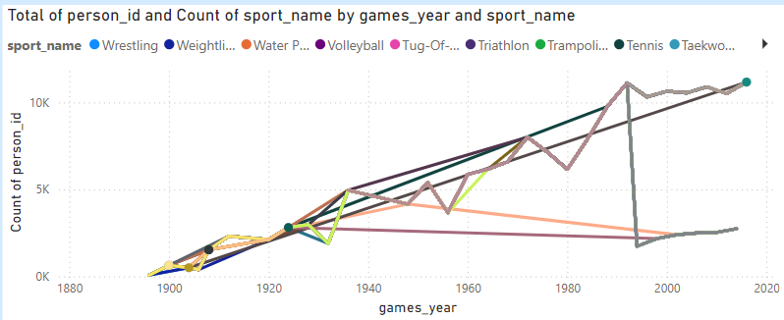

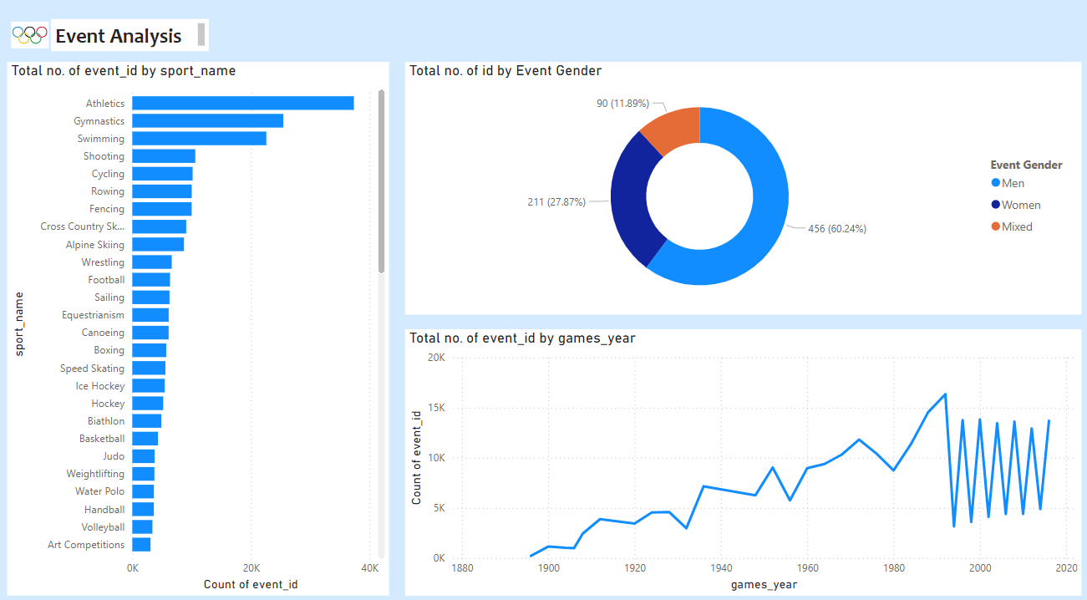

1. How many events are there in each sport?

We can determine the number of events in each sport by analysing the Sport and Event tables. The Sport table lists all Olympic sports, while the Event table categorizes the specific competitions within each sport. By counting the number of events linked to each sport, we can identify those with the highest event counts. Athletics has the most events, covering sprints, distance races, jumps, and throws. Swimming follows closely, featuring multiple strokes and distances for both men and women. Cycling includes road and track, contributing to a high number of events. Gymnastics has artistic, rhythmic, and trampoline events, making it one of the largest disciplines. Combat sports like Judo, Boxing, and Wrestling have numerous events based on weight categories. Shooting and Fencing also have several events due to multiple disciplines and formats. The dataset shows that sports with multiple weight classes, race distances, or disciplines tend to have the highest number of events.

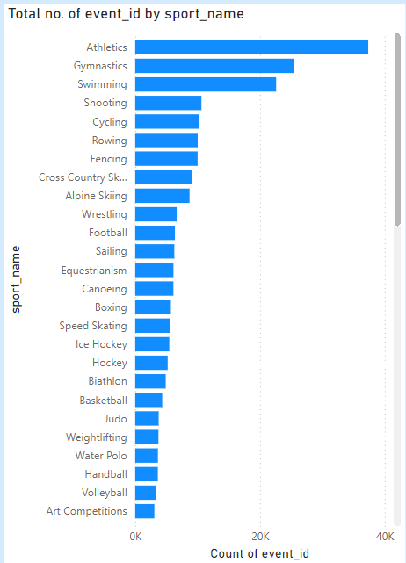

1. What is the distribution of events by gender (Men, Women, Mixed)?

Distribution of events by gender using the Event table, which includes a field for Event Gender. The dataset categorizes events into Men’s, Women’s, and Mixed competitions. Historically, Men’s events were more numerous, but Women’s participation has steadily increased over time. Many sports, such as Athletics, Swimming, and Gymnastics, now have nearly equal events for men and women. Combat sports like Boxing and Wrestling have expanded Women’s events by adding more weight categories. Mixed events, where men and women compete together, have been introduced in sports like Tennis, Badminton, and Equestrian. Team sports such as Mixed Doubles in Table Tennis and Mixed Relays in Athletics and Swimming have also gained popularity. The dataset shows a trend towards gender balance, with more Women’s and Mixed events added in recent editions. Some sports, like Shooting and Archery, have replaced separate Men’s and Women’s events with more Mixed competitions. Overall, the Olympic Games have evolved to promote inclusivity across all event categories.

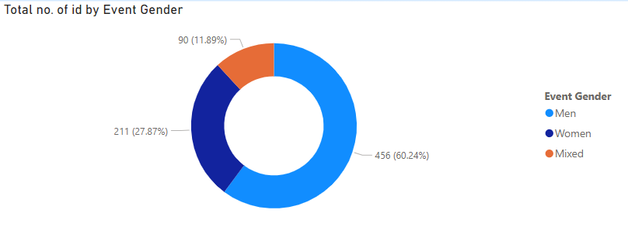

1. How has the number of events changed over time?

We can track changes in the number of events over time using the Games and Event tables. The Games table records each Olympic edition, while the Event table lists the competitions held in each sport. The number of events has steadily increased, reflecting the expansion of the Olympic program. Early editions had fewer events, primarily focused on Athletics, Gymnastics, and Swimming. Over time, new sports like Basketball, Judo, and Taekwondo were introduced, increasing the event count. Women’s events and Mixed competitions have also contributed to the rise in total events. Some sports, like Cycling and Weightlifting, expanded by adding new disciplines and weight categories. The dataset shows that certain sports, like Tennis and Golf, were reintroduced after being discontinued for several editions. Team sports have seen event growth with separate Men’s and Women’s competitions. Overall, the Olympic Games have evolved with a continuous increase in the number of events, reflecting the diversity of sports and athlete participation.

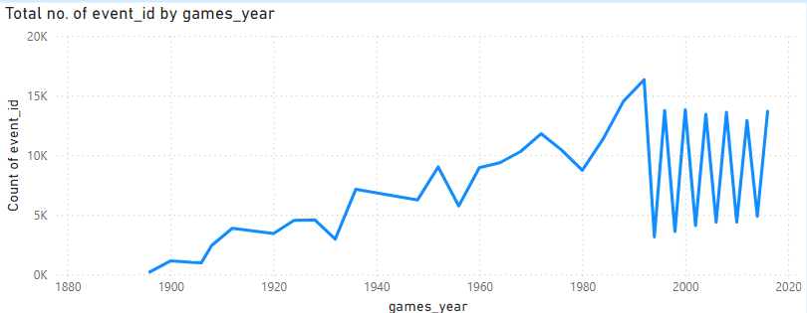

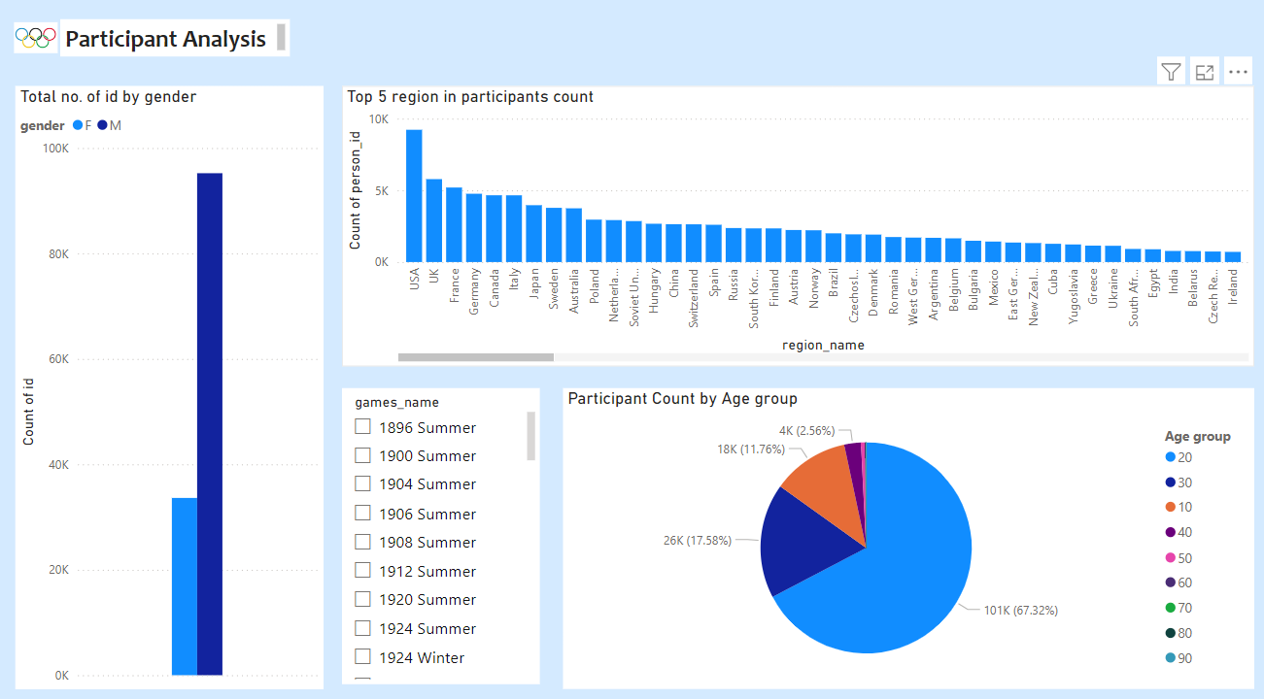

1. What is the distribution of participants by gender?

Early editions had predominantly male competitors, but female participation has grown steadily. The Person table captures gender data, allowing for analysis of trends over different Games. The Games Competitor table links individuals to specific Olympic editions, enabling a breakdown of male and female athletes over time. Gender distribution varies by sport and event, with some sports achieving near-equal representation. Mixed-gender events have also emerged, contributing to a more inclusive competition landscape. Certain sports, like gymnastics and figure skating, historically have higher female representation. Conversely, events such as weightlifting and wrestling have had higher male participation. The dataset highlights the impact of evolving Olympic policies promoting gender balance. Overall, the trend indicates continuous progress toward greater inclusivity in global sports.

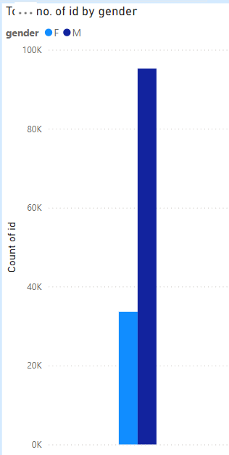

1. Which countries have the highest number of participants in the Olympics?

The dataset reveals that countries with large populations and strong sports programs have the highest number of Olympic participants. The NOC Region table links each athlete to their respective country, allowing for an analysis of participation trends. Host countries often see a spike in participation due to automatic qualifications and increased investment in athletes. European nations such as Germany, France, and the United Kingdom have historically maintained strong representation. Team sports, such as basketball and football, further increase participant counts for major sporting nations. Over time, participation numbers have grown due to expanded events and broader global representation. The dataset highlights the dynamic nature of Olympic participation, showcasing the diversity of nations competing on the world stage.

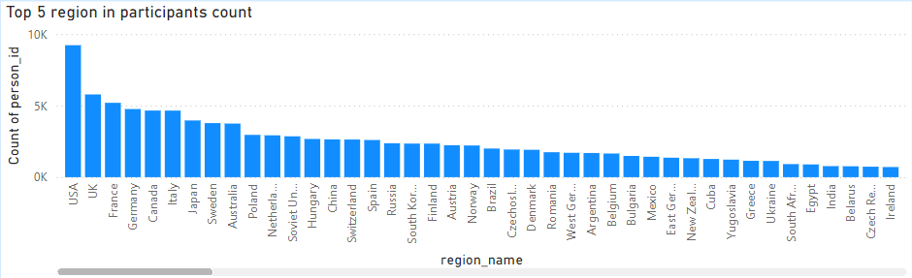

1. How does the age distribution of participants vary across different games?

The dataset provides insights into the age distribution of Olympic participants across different editions of the Games. The Games Competitor table records the age of athletes, allowing for analysis of trends over time. Younger athletes are more common in sports requiring agility and flexibility, such as gymnastics and swimming. Older athletes tend to compete in endurance-based events like marathon running and equestrian sports. The average age of participants varies by sport, with some disciplines favouring peak physical performance in specific age ranges. Over time, improvements in training and sports science have extended the competitive careers of many athletes. Certain Olympic editions have seen a wider age range due to the inclusion of new sports with varying physical demands. The introduction of age-group categories in some sports has also influenced participation patterns. Historical trends show that the overall average age of competitors has gradually increased. This dataset highlights the evolving nature of age demographics in Olympic competition.

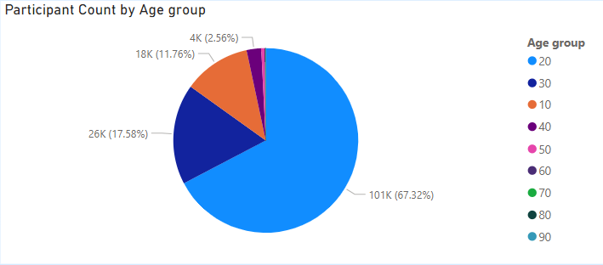

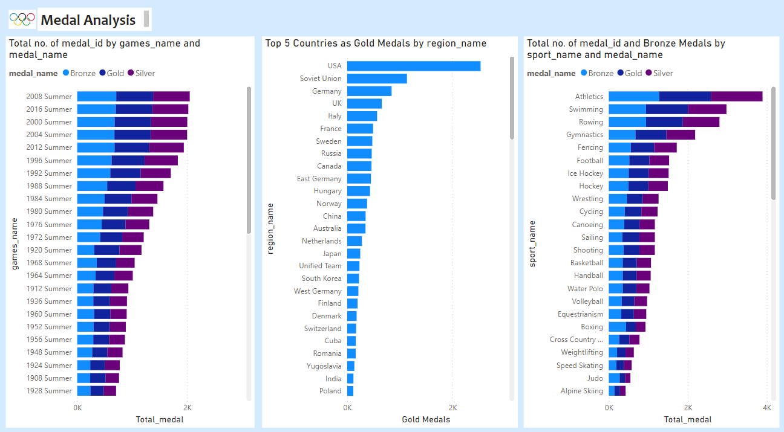

1. How many medals have been awarded in each Olympics?

The dataset provides detailed records of medals awarded in each Olympic edition through the Medal and Competitor Event tables. Each competitor's performance is linked to their event and medal type, allowing for an analysis of total medals distributed. The number of medals awarded varies based on the number of sports, events, and participating athletes. Early Olympic Games had fewer sports and events, resulting in a lower total medal count. Over time, the introduction of new sports and additional events increased the overall number of medals. Team events contribute multiple medals per competition, significantly impacting the total count. Some Olympic editions, especially recent ones, have seen record-high medal distributions due to event expansions. Host nations often introduce new sports, temporarily influencing medal counts in those years. The dataset highlights the evolution of medal distribution as the Olympics have grown. Overall, the trend shows a steady rise in awarded medals, reflecting the increasing scale of the Games.

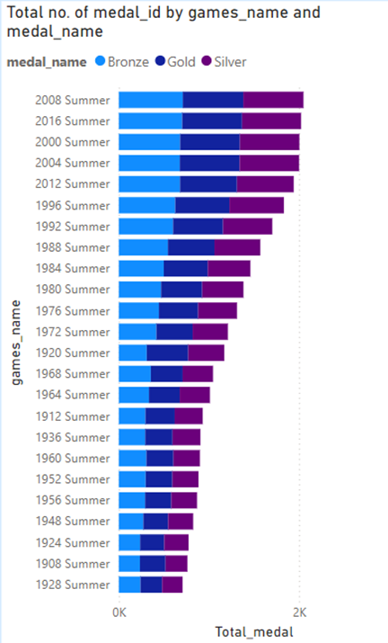

1. Which countries have the highest number of gold medals?

The dataset tracks gold medal achievements through the Medal and Competitor Event tables, linking winners to their respective countries. Nations with strong sports programs, such as the United States, Russia, and Germany, consistently top the gold medal count. The NOC Region table connects each athlete to their country, enabling an analysis of national success over time. Host countries often see an increase in gold medals due to home advantage and larger athlete delegations. Team events further boost medal counts for countries with strong collective performances. Historical trends show a steady rise in gold medal distribution as new sports and events are introduced. Countries with established training programs and elite athlete development consistently produce gold medalists. The dataset highlights long-term dominance by specific nations while showcasing emerging competitors in various disciplines.

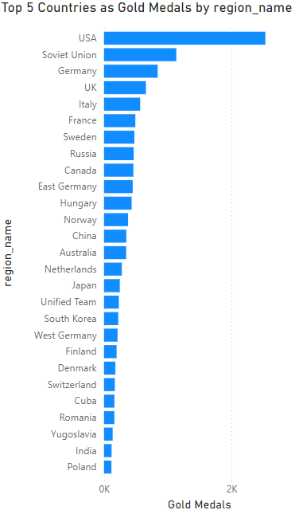

1. How does the medal distribution vary across different sports?

The dataset provides insights into medal distribution across different sports using the Medal, Sport, and Competitor Event tables. Some sports, like athletics and swimming, have a high number of medal events, leading to more total medals awarded. Team sports such as football and basketball award fewer medals but contribute significantly to overall country rankings. Individual sports tend to have more medal opportunities than team-based events due to multiple disciplines within each category. Newer sports introduced in recent Olympic editions have gradually influenced overall medal distribution trends. Certain nations specialize in specific sports, leading to concentrated medal wins in those disciplines. Historical trends show that as the Olympics expand, the diversity of medal-winning sports increases. The dataset highlights the evolving nature of medal distribution across various athletic disciplines

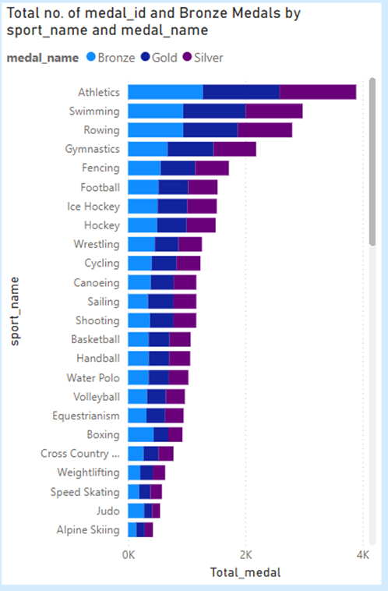

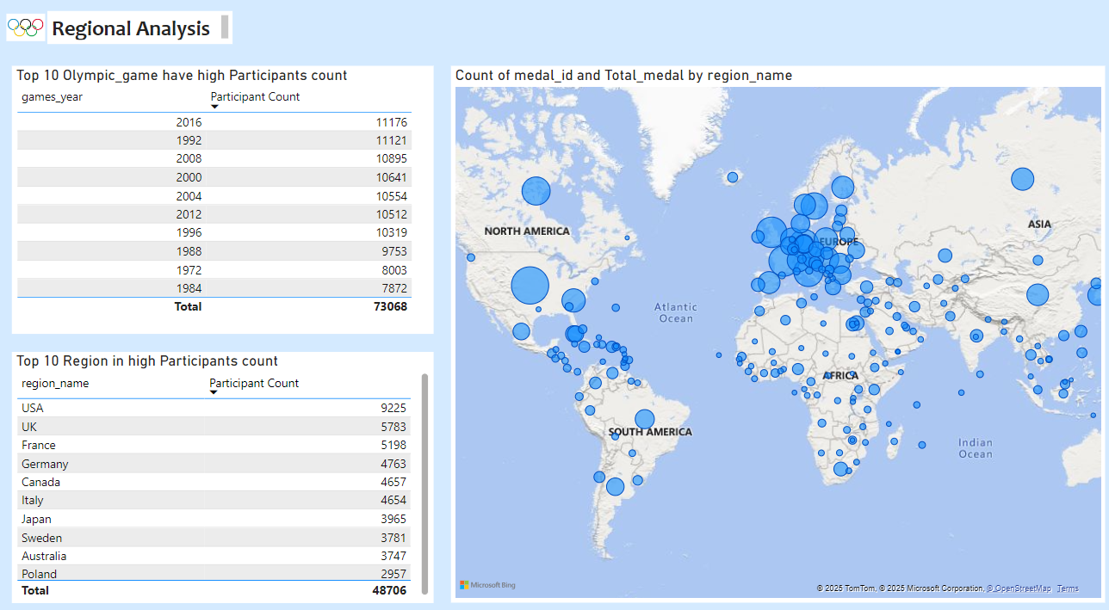

1. How many regions or NOCs participate in each Olympic Games?

The dataset tracks participating regions and National Olympic Committees (NOCs) through the NOC Region and Games Competitor tables. Each Olympic edition features a varying number of NOCs based on global participation and sports expansion. Early Games had fewer NOCs, but participation steadily increased as more nations joined. The number of competing regions often rises when new countries gain recognition or establish Olympic committees. Certain sports, like athletics and swimming, attract nearly all participating NOCs due to their universal appeal. The dataset shows a gradual increase in the diversity of participating regions over time. Multi-sport events and team-based competitions contribute to the overall NOC count in each edition. The trend highlights the Olympics’ role in bringing together a growing number of nations through sports.

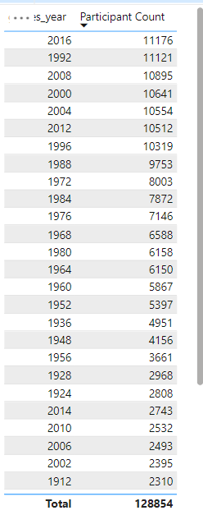

1. Which regions have the highest number of participants in the Olympics?

The dataset records Olympic participation by region through the NOC Region and Games Competitor tables. Regions with strong sports programs and large populations, such as the United States, China, and Russia, consistently have high participant counts. European countries like Germany, France, and the United Kingdom also maintain strong representation across multiple Olympic editions. Host nations often experience a surge in participation due to automatic qualifications and increased athlete support. Team sports contribute significantly to participation numbers, as each event requires multiple athletes per team. Over time, the number of participating athletes has increased due to the inclusion of new sports and events. The dataset shows that regions with established Olympic programs sustain high athlete representation across multiple games. The overall trend highlights the increasing diversity and global reach of Olympic participation.

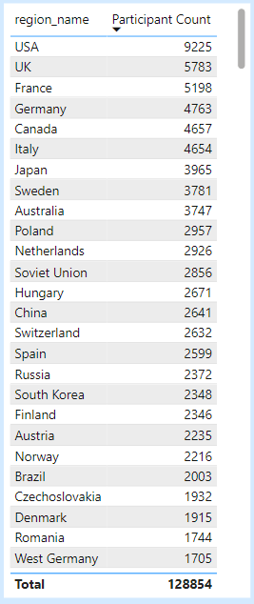

1. What is the distribution of medals among different regions?

The dataset tracks medal distribution among regions using the Medal, Competitor Event, and NOC Region tables. Regions with strong sports programs, such as the United States, European nations like Germany, France, and the United Kingdom have historically secured a high number of medals across various sports. Some regions specialize in particular disciplines, such as Kenya in long-distance running and Jamaica in sprinting. Host nations often see a temporary rise in medal wins due to increased athlete participation and home advantage. Team sports contribute significantly to medal counts, as multiple athletes receive medals for a single event. Combat sports like boxing and judo award multiple bronze medals, influencing regional medal distributions. Over time, the expansion of Olympic events has allowed more regions to achieve medal success. The dataset highlights a gradual increase in medal-winning regions, reflecting greater global competition. Trends show that regions with strong athletic development programs consistently perform well across multiple Olympic editions.

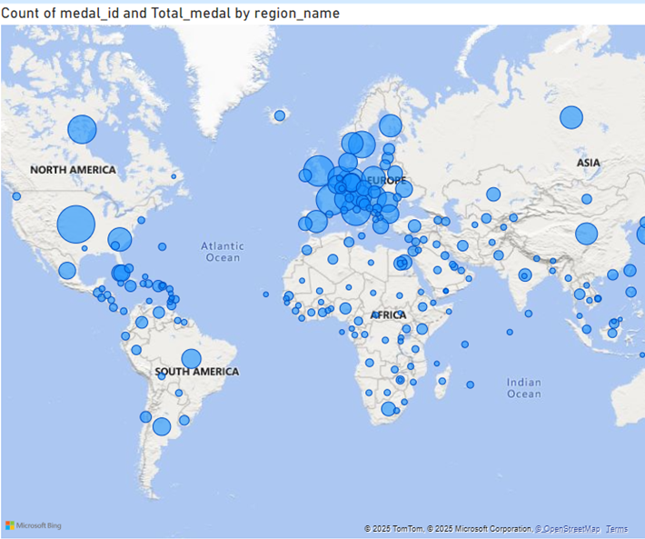

**EDA questions**

1. Are there any trends or patterns in the frequency of hosting Olympic Games?

Locating Cities with Multiple Olympic Hosting Cities that held the Olympics more than once are found with this query. The two cities that have hosted the most Olympic Games—London and Athina have done it three times. Two Olympic Games have been held in Paris, Los Angeles, Lake Placid, Stockholm, Innsbruck, and Sankt Moritz.

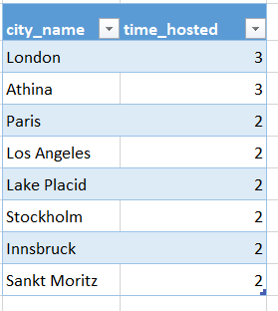

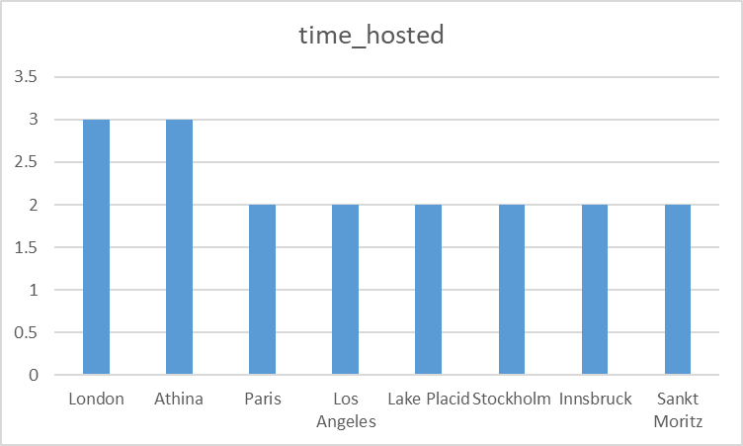

1. How has the duration of Olympic Games changed over time?

The majority of the Olympic Games were held in the winter in the past, however today the for a considerable amount of time, the way the Olympic Games are held has evolved. As of the 20s, the majority of the games are held in the summer as well as winter and the number of events at the Olympics keeps growing. It has been demonstrated that the 20’s Olympics featured more orderly events.

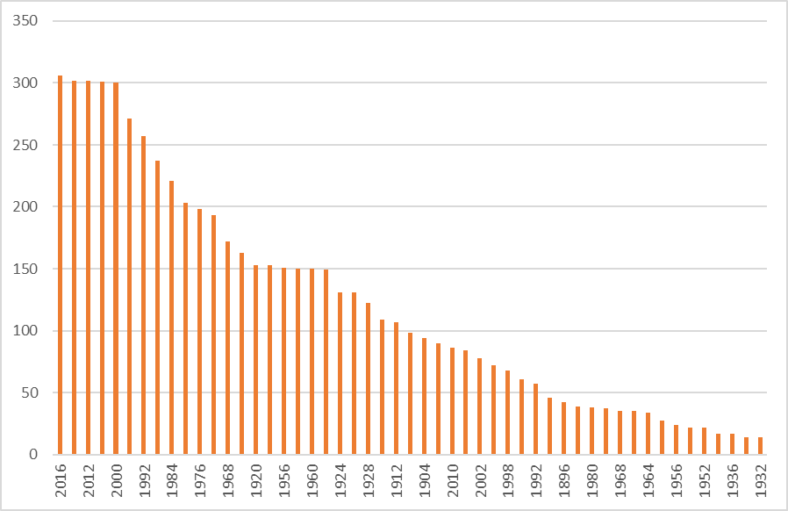

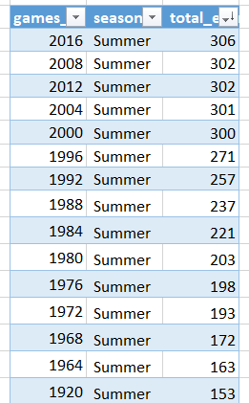

1. Are there any notable events or occurrences associated with specific Olympic Games?

The top 10 athletes who have won the most Olympic medals in the particular Olympic game are displayed in this query, thus first we may Aleksandr Nikolayevich Dityatin and Michael Fred Phelps II are the most medal winners with eight medals overall from a particular Olympic Games. Next up are those who have won seven medals overall in particular Olympic gains. Mark Borys Anfiyanovych Shakhlin, Andrew Spitz, Mikhail Yakovlevich Voronin, and Matthew Nicholas the chart lists Matt Biondi, Willis Augustus Lee Jr., Lloyd Spencer Spooner, Mariya Kindrativna Horokhovska, and the game of the year they won.

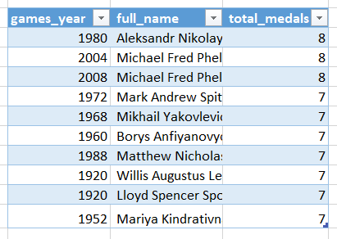

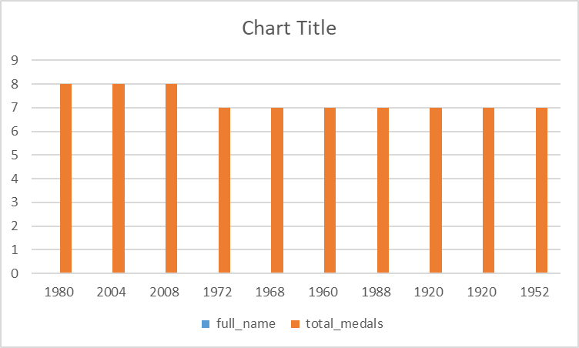

1. Are there any emerging sports that have been recently added to the Olympics?

The top 10 recently added sports editions are returned in this query. As you can see, the games that were added by the most recent year are rugby sevens, trampolining, triathlon, Taekwondo, snowboarding, softball, beach volleyball, short track speed skating, freestyle skiing, and badminton. In order to identify the oldest Olympic edition (MIN(g.games_year)) in which each sport was introduced, this query will emphasize sports that were launched in the most recent Olympic editions.

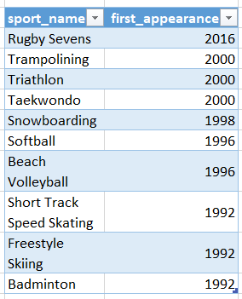

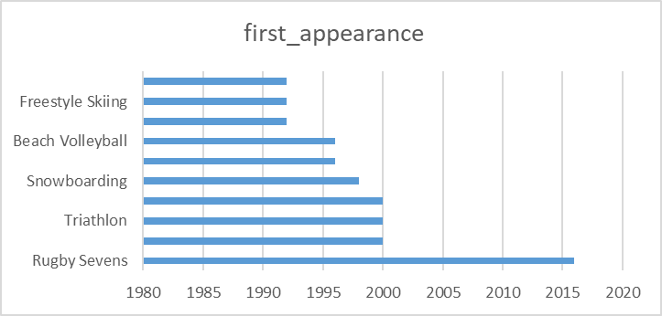

1. How has the popularity of certain sports changed over the years?

The number of participants in each sport, categorized by Olympic game year, will be returned by this query. Athletics, gymnastics, rowing, shooting, tennis, cycling, fencing, swimming, and weightlifting have the highest participation rates. The sport year is added to the slicer to filter the appropriate year for each sport event in the Olympic year, allowing us to find the returns with the highest number of participants. The top three sports with the highest participation counts are athletics, gymnastics, and Rowing.

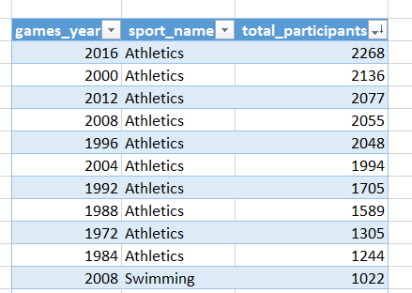

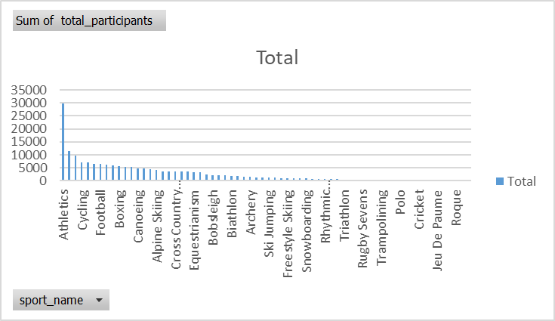

1. Are there any sports that are specific to a particular region or culture?

Athletics, swimming, and rowing have the highest participation rates among the three sports. shows that the USA is the top competitor in this particular sport and holds the second-most-dominant position in terms of participants followed by the UK.

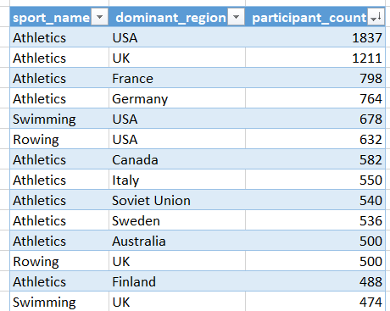

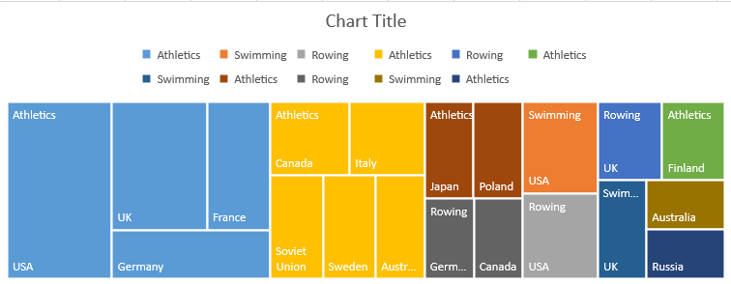

1. Are there any sports that have a higher number of events for one gender compared to others?

These are the top five sports with a higher number of male participants than females are athletic, gymnastic, swimming, cycling, and fencing. The tree map clearly displays the distribution of male and female athletes' participation rates.

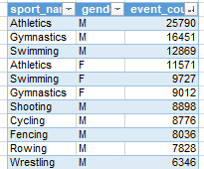

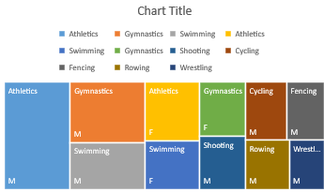

1. Are there any new events that have been introduced in recent editions of the Olympics?

In this query we will return the new event that has been introduced in the recent edition of this Olympic which is gymnastics men's individual all-around that is the new event edition add in the Olympics

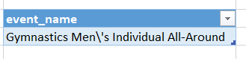

1. Are there any events that have been discontinued or removed from the Olympics?

This query we will return the event that has been discontinued or removed from the Olympic Games these are the list of events that has been discontinued in the Olympic Games In the recent edition of Olympics Which is the comparison between the recent Olympic events and the previous ones

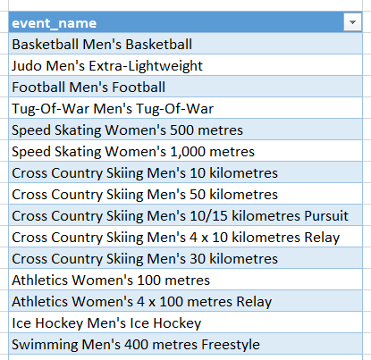

1. Are there any notable trends in the height and weight of participants over time?

This will show the notable trend in the participant's weight and height over time. When comparing the height of the athlete from the previous Olympic Games to the most current ones, there have been noticeable increases in the average height. It has been demonstrated that the average height of the participants has changed noticeably throughout the extended period of time. There is a modest increase in the average weight in the mid-1960s, but there is a large increase in the average weight in the mid-1960s. In contrast, the average weight has been steady in the recent games from 1960 to 2016.

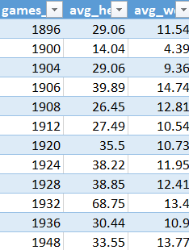

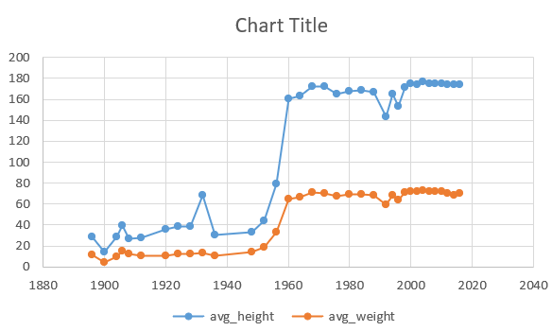

1. Are there any dominant countries or regions in specific sports or events?

Sweden dominates the ice hockey world in terms of medals won. India dominates the highest medal winnings in hockey, whereas the United States dominates the best medal winnings in arts competitions. Hungary leads the world in water polo medals, while the United Kingdom leads the world in rowing medals.

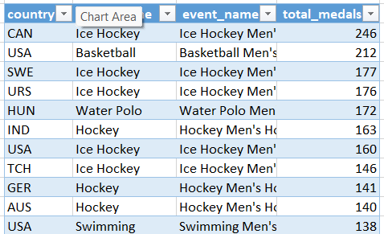

1. What factors contribute to the success or performance of participants from different countries?

USA, Soviet Union and Germany are the top 3 countries which won the greatest number of medals in the Olympic Games in over the time. The average hight weight and age which supports the participants to score more number of medals and increased in participant count for these three countries is also one significant which helps to win more medals when compare to the all-other countries

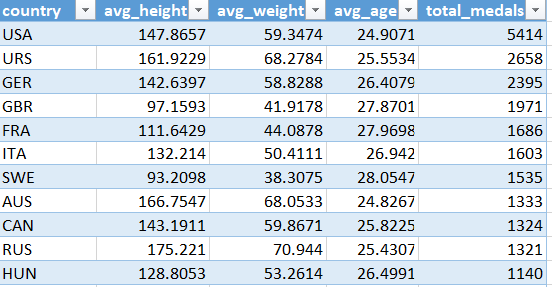

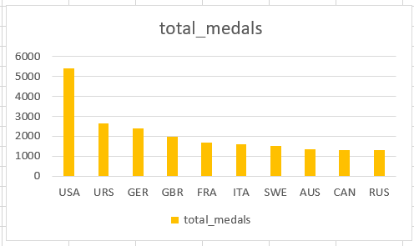

1. Are there any countries that consistently perform well in multiple Olympic editions?

Russia, USA and UK are some countries that shown the good performed over the year number of medals in the Olympic Games in over the time and increased in participant count for these three countries is also one significant which helps to win more medals when compare to the all-other countries

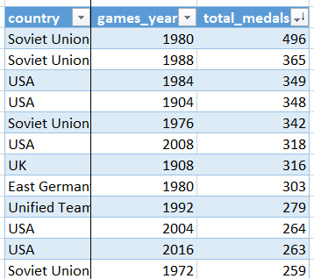

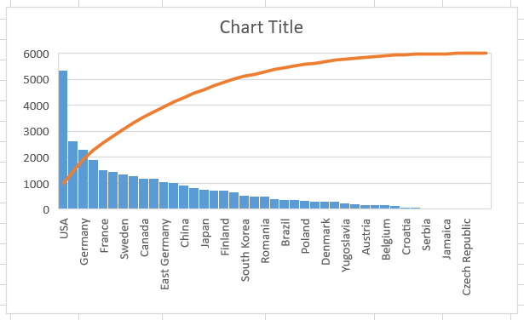

1. Are there any sports or events that have a higher number of medallists from a specific region?

This query returns the high number of medallists for specific region which shows that the we take participant count as the medallist USA is dominant in Ice Hockey and India is dominant in hockey and football is dominant in Italy and rowing is dominant in UK, which here that concludes that the participant count this taken for each region to count the medallist when it comes to higher number of medals count the participants may be repeated in some regions.

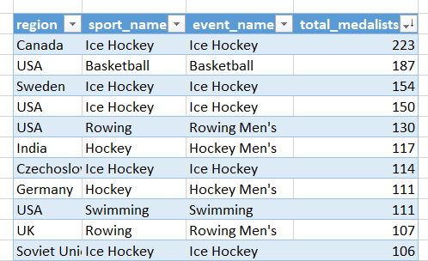

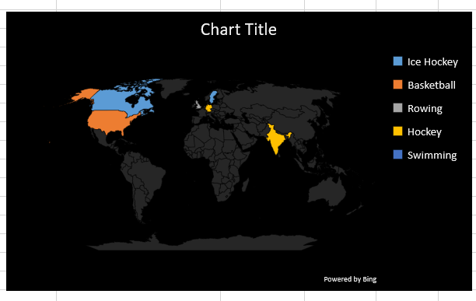

1. What are some notable instances of unexpected or surprising medal wins?

This query gives us the comparison between the average medals winning by the countries for the specific sports. This gives us the USA and Sweden and UK are the top 3 countries gives a consistency higher medal count compare to the Average medal count for the specific sport and countries, This Also gives us for the specific Olympic games year.

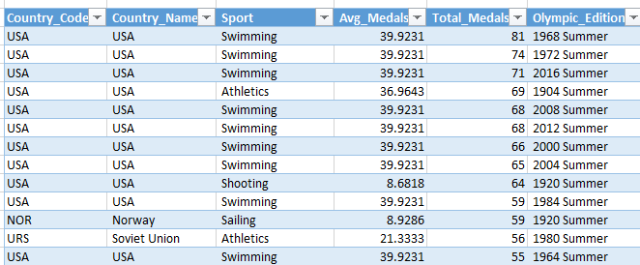

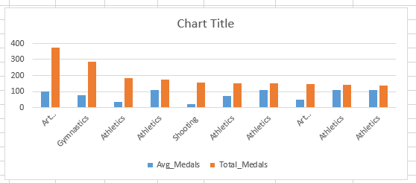

1. Are there any regions that have experienced significant growth or decline in Olympic participation?

New foundland, North Borneo, South Sudan and South yamen these are the regions have very least number of participant count and USA, UK, France, Germany and Italy have the more participant count in Olympic Games which has shown that the Olympic game participant count is continuously increasing over the period of time.

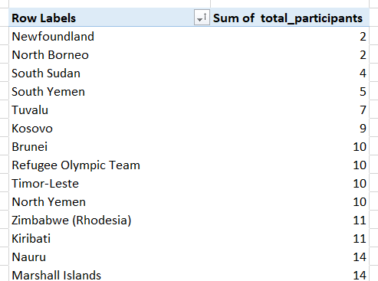

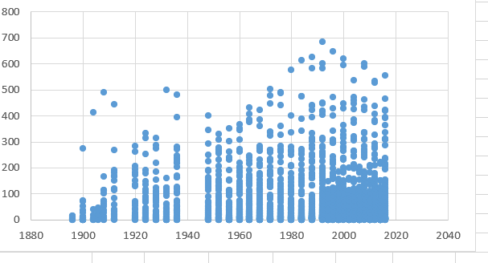

1. How do cultural or geographical factors influence the performance of regions in specific sports?

When it comes to summer season Olympic Sports USA UK France are the top 3 medal winning regions and when it comes to winter season Olympic sports USA Canada Italy are the countries holding the top 3 medal winning regions. This shows that USA place the predominant role in winning medal in both winter and summer season.

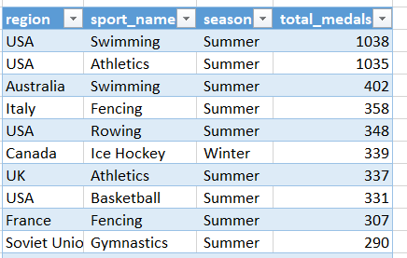

1. Are there any regions that have had a notable impact on the overall medal tally?

USA, UK and France are the top 3 countries which won the greatest number of medals in the Olympic Games in over the time and increased in participant count for these three countries is also one significant which helps to win more medals when compare to the all-other countries. When it come to the high number of gold medal winning USA is first, Soviet Union on the second the greatest number of gold medal winning, Germany is 3rd.

